Recordings of the webinars are available with closed captioning on YouTube. Click on the image or the title of the session to view the recordings.
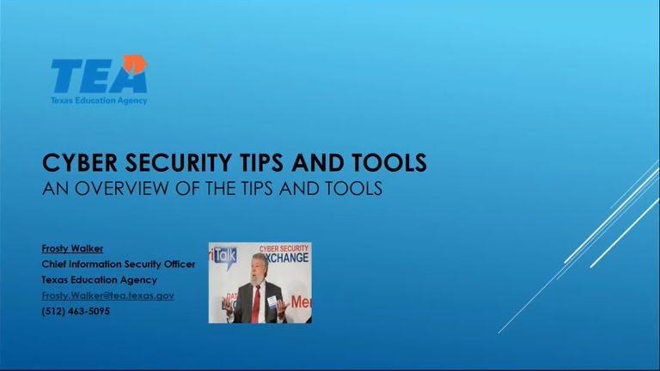
Cybersecurity Tips and Tools “An Overview of the Tips and Tools” - Session 1
This presentation from March 7, 2017 will cover an overview of the Tips and Tools currently being shared for all Texas education communities. This presentation is being conducted by TEA and led by TEA's Chief Information Security Officer, Frosty Walker, in collaboration with the Data Security Advisory Committee to provide insight to the Cyber Security Tips and Tools.

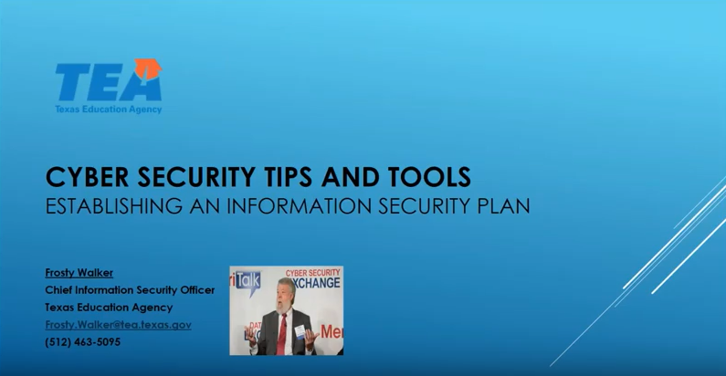
Cybersecurity Tips and Tools “Establishing an Information Security Plan” – Session 2
This presentation from April 12, 2017 will cover establishing an Information Security Plan and how to use the Information Security Plan tool shared for all Texas education communities. This presentation is being conducted by TEA and led by TEA's Chief Information Security Officer, Frosty Walker, in collaboration with the Data Security Advisory Committee to provide insight to the Cyber Security Tips and Tools.
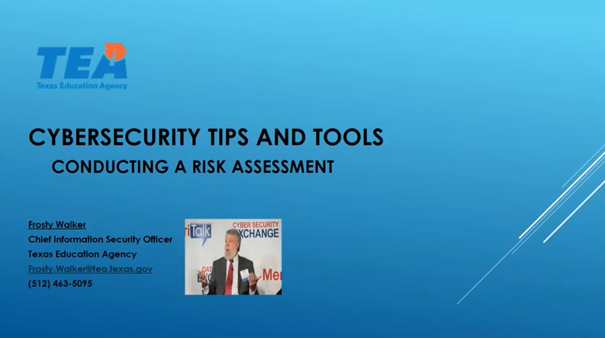
Cyber Security Tips and Tools “Conducting a Risk Assessment”- Session 3
This presentation from May 10,2017 will cover conducting a Risk Assessment and using the Risk Assessment tool shared for all Texas education communities. This presentation is being conducted by TEA and led by TEA's Chief Information Security Officer, Frosty Walker, in collaboration with the Data Security Advisory Committee to provide insight to the Cyber Security Tips and Tools

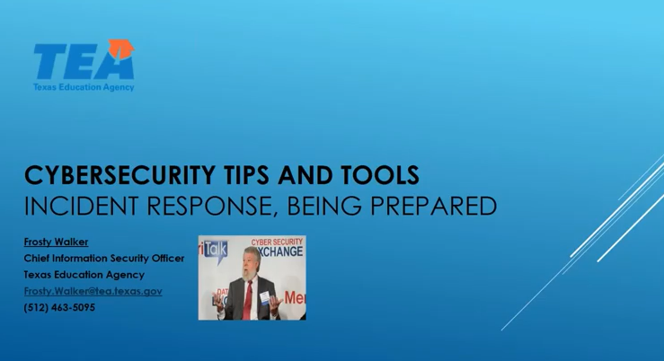
Cybersecurity Tips and Tools “Incident Response, Being Prepared”- Session 4
This presentation from September 13, 2017 will cover Incident Response readiness. When a cybersecurity incident occurs, it is imperative to follow documented procedures to process the incident. Understanding the life cycle of an incident and how to use the Incident Red Team (IRT) Redbook which contains the procedures and plans for such incidents can be critical for success. This presentation is being conducted by TEA and led by TEA's Chief Information Security Officer, Frosty Walker, in collaboration with the Data Security Advisory Committee to provide insight to the Cybersecurity Tips and Tools.

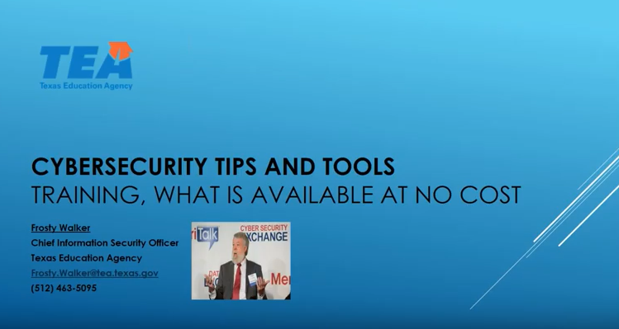
Cybersecurity Tips and Tools “Training, What is Available at no Cost” – Session 5
This presentation from October 11, 2017 will cover training such as FERPA training for staff, and cybersecurity training covering Vulnerability Management, Protecting Information Assets and End User Security Awareness, all of which are available at no additional cost to the Texas education communities. This presentation is being conducted by TEA and led by TEA's Chief Information Security Officer, Frosty Walker, in collaboration with the Data Security Advisory Committee to provide insight to the Cybersecurity Tips and Tools.

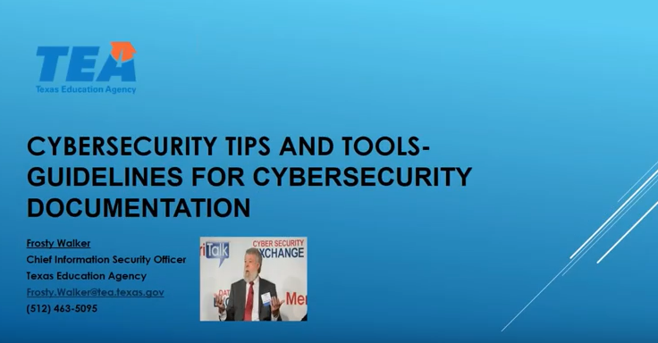
Cybersecurity Tips and Tools “Guidelines for Cybersecurity Documentation” – Session 6
This presentation from November 8, 2017 will cover how security documentation such as policies, strategic planning, tactical planning and operational planning provide a common framework to achieve organizational goals. This presentation is being conducted by TEA and led by TEA's Chief Information Security Officer, Frosty Walker, in collaboration with the Data Security Advisory Committee to provide insight to the Cybersecurity Tips and Tools.

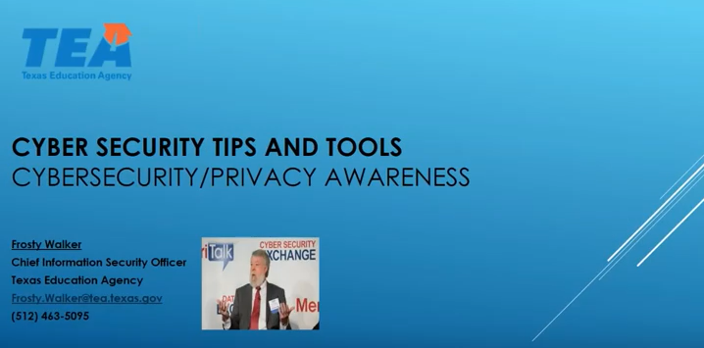
Cybersecurity Tips and Tools “Cybersecurity/Privacy Awareness” - Session 7
This presentation from March 7, 2018 provides information needed for a successful Cybersecurity/Privacy Awareness program and why a Security/Privacy Awareness program is key in protecting student, parent and staff information. This presentation is being conducted by TEA and led by TEA's Chief Information Security Officer, Frosty Walker, in collaboration with the Data Security Advisory Committee to provide insight to the Cybersecurity Tips and Tools.
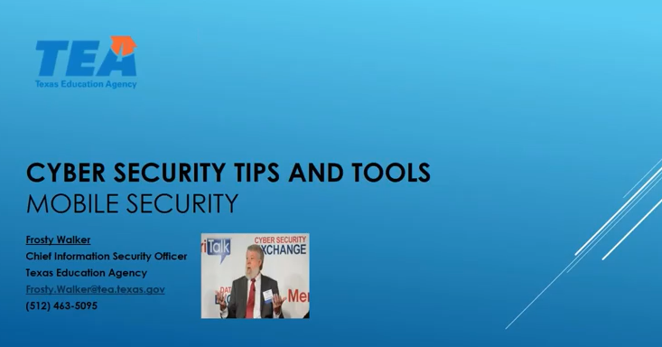
Cybersecurity Tips and Tools “Mobile Security” – Session 8
This presentation from April 11, 2018 provides information regarding securing mobile devices. Whether mobile devices are provided by your organization or you have a Bring Your Own Device (BYOD) policy, measures need to be implemented to adequately protect our information. This presentation is being conducted by TEA and led by TEA's Chief Information Security Officer, Frosty Walker, in collaboration with the Data Security Advisory Committee to provide insight to the Cybersecurity Tips and Tools.
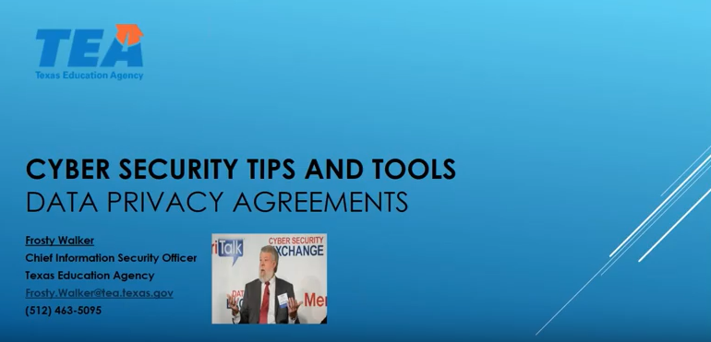
Cybersecurity Tips and Tools “Data Privacy Agreements” – Session 9
This presentation from May 9, 2018 provides information regarding Data Privacy Agreements and what needs to be included in our agreements with vendors and third parties to help you protect student, parent and staff information. This presentation is being conducted by TEA and led by TEA's Chief Information Security Officer, Frosty Walker, in collaboration with the Data Security Advisory Committee to provide insight to the Cybersecurity Tips and Tools.

